**Open Channel Flow**

**I. Introduction**

Determination of the ﬂow rate of water in open channels is signiﬁcant in many aspects of society. For example, urban and industrial water supplies must be measured so that demands are satisﬁed; the amount of water required for the dilution of pollutants being wasted into a river can be calculated mathematically, but metering devices are required to measure the supplied ﬂow; and ﬂood damage can be determined by correlating the depth of water passing over a dam spillway (a special type of weir) to the volume of water ﬂowing downstream.

A weir is a vertical obstruction placed in an open channel, normal to the mean ﬂow, thus forcing the ﬂow over a crest designed to measure the ﬂow rate. A well designed weir will exhibit subcritical ﬂow upstream, accelerating to critical ﬂow at the crest. For more information on subcritical and supercritical ﬂow, this experiment will consider one class of weirs, known as sharp-crested weirs, which are smooth, vertical, ﬂat plates with a sharpened upper edge. In particular, rectangular and triangular weirs will be studied.

Consider a schematic diagram of ﬂow over a weir (Figure 12). Among the complicated features of the ﬂow are:

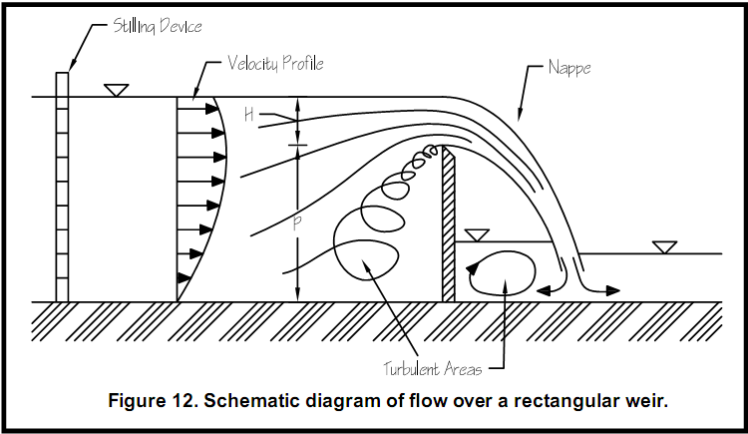

(1) upstream velocity proﬁle which varies over the vertical;

(2) curved streamlines over the crest;

(3) potentially inadequate ventilation under the nappe, which may result in

subatmospheric pressure there;

(4) secondary ﬂows and other turbulent processes;

(5) surface tension

For a ﬁrst analysis, the problem is greatly simpliﬁed by neglecting these complicating features. A diagram of the simpliﬁed ﬂow is shown in Fig.

Speciﬁcally, simpliﬁcations include:

(1) Uniform upstream velocity proﬁle (generally valid for H/P <0.4 );

(2) Straight, horizontal streamlines over the crest;

(3) Good ventilation, and therefore atmospheric pressure, under the nappe;

(4) neglect of secondary ﬂows and other turbulent processes;

(5) Neglect of surface tension (generally valid for H>3cm ).

Simpliﬁcations (2) and (3) indicate that the ﬂow over the weir may be treated as a jet. Note that the velocity proﬁle over the crest is still not uniform.

